

Therapeutic Recreation
FORMS MUST BE FULLY COMPLETED TO ATTEND! NO EXCEPTIONS.
FLING
S
P
R
I
G
N
Family Reunion Edition

Dear Teachers, Parents, Paraprofessionals, and Friends,
Get ready to come together, because the Annual Spring Fling Fun Day is returning—and this year, we’re celebrating with a Family Reunion theme! Last year’s Western-themed festivities were a huge hit, and we loved seeing both familiar faces and new friends. In 2026, we’re bringing that same energy and excitement as we gather for a day full of connection, fun, and community spirit. Please mark your calendar for Friday, March 20, 2026, with a make-up date of Friday, March 27, 2026. Every child will receive a Cousins Candy Collection, packed with assorted treats, eggs, and candy; each bag will be labeled with the school and teacher’s name and will be available at the designated table. We can’t wait to welcome everyone back for another unforgettable Spring Fling!

We will greet your bus in front of the Daffin Park Administration office. Buses will exit at Warning Drive going out onto Victory Drive. Chairs and tables will be provided for each class. Teachers and students will be able to purchase items from the “Kona Ice” truck. They will be accepting CASH ONLY. We hope this day will be full of fun, sun, music, goodies, vendors, and excitement!

All students/classes are responsible for bringing their own lunch. Please bring hand sanitizer as well. Survey forms can be returned to the registration table or any staff member on the day of the event. This information will help us plan for next year.

Pictures will be taken during the event by staff, and various news media may be present. Participation in the Therapeutic Recreation Program and our Special Events requires providing names, addresses, and birthdates.

Please read all the information carefully and thank you for allowing us to serve you. If you have questions, please call our office at (912)651-6791, (912) 651-6792, or cells at (912) 547-1164, 912-547-3267, or 912-655-4682.

Please call and confirm your information has been received. Our purchases are determined by the number of people we expect based on the paperwork we receive. As an incentive, the first class in each grade level (Pre-K, Elementary, Middle, and High School) to complete all required paperwork in its entirety and submit it will receive a pizza party.
To better serve you, we have REMIND! To join, send the message “@youthparti” to 81010 and follow the prompts. Or you can provide your cell number and/or email, so we can inform you of any changes or cancellations of the event. If you do not check your emails often, please send your cell number.


FLING
S
P
R
I
G
N
Family Reunion Edition

March 20, 2026

Please complete and return this form by Wednesday, March 4, 2026, by noon to ensure we can order sufficient supplies to meet the needs of our guests. Your help is appreciated.

Please email the information to Kierra.carter@savannahga.gov or VGreen@Savannahga.gov or fax 912-351-3423.

The Spring Fling Fun Day: Family Reunion edition activities are for all school-age youth who are Learning Disabled. The activities will be held in Daffin Park Circle (Entrance from Washington Ave. near Grayson Stadium). WARNING! Waring Drive will be blocked off: therefore, you will not be able to turn around. PLEASE COMPLETE ALL THE INFORMATION IN THIS PACKET, INCLUDING THE REGISTRATION FORM(S), COMPLETELY. If you have questions, call (912) 547-1164 or 912-547-3267.

School__________________________________________________________________

Telephone #____________________________ EXT._____________________________

Contact Person 1__________________________________________________________

Email Address

Contact Person 2__________________________________________________________

Email Address

Number of Students________

Number of Staff (including bus drivers) ________

Total_____________
FORMS MUST BE FULLY COMPLETED TO ATTEND! NO EXCEPTIONS.

P.O. BOX 1027, SAVANNAH, GA 31402
PHONE 912.651.6791/651-6792 TDD 912.651.6702 FAX 912.651-6791 OR 912-525-1685 SAVANNAHGA.GOV

City of Savannah
Recreation & Leisure Services, Therapeutic Recreation Program
ITINERARY
Group I: Wheelchairs
10:00 AM – 10:15 AM Egg Hunt
10:15 AM – 10:30 AM – The Family Market (Store)

Group II: Pre-K
10:40 AM – 11:00 AM Egg Hunt
11:00 AM – 11:20 AM -The Family Market (Store)

Group III: Middle School & High School
11:30 AM – 11:50 PM Egg Hunt
11:50 AM – 12:10 PM The Family Market (Store)

Group IV: Physically Challenged & Elementary School
12:20 PM – 12:40 PM Egg Hunt
12:40 PM – 1:00 PM The Family Market (Store)

LUNCH AT 11:30 / 12 NOON!!!

The itinerary may be adjusted due to an unexpected number of participants and/or late arrivals. We will try to accommodate late arrivals. If you are delayed, follow the above itinerary at your arrival time. Please make every effort to be on time. There will be a lot to do, and we don’t want you to miss any activities!

Staff will be limited; please, help when you can.

Kona Ice Price List
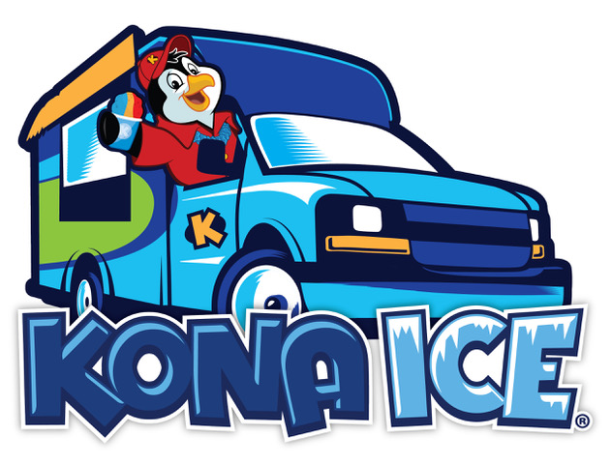
Prices range from $4-$7 with four (4) different CUP SIZES.

Spring Fling Vendors & Volunteers
Savannah Fire Department
Savannah Police Department





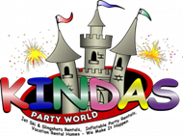

Firefighters and Firetrucks
Mount Units, Patrol Cars, Police Officers, K-9 units
Spring Fling Activities and Games


Face Painting
Hula-Hoops
Parachute Drop



And Much More!!!
Inflatable Obstacle Course and Bounce House
Egg Hunt
NAME | ADDRESS | ZIP CODE | WHEELCHAIR  (Y/N)  ATHLETIC TEAMS ONLY  COACH __________________________________________________  ADDRESS ________________________________________________  PHONE __________________________________________________  ASS’T COACH _____________________________________________  ADDRESS ________________________________________________  PHONE __________________________________________________ | B/W/O | M/F | AGE CODE | BIRTHDATE  (M/D/YR)
FORM MUST BE FULLY COMPLETED TO ATTEND! NO EXCEPTIONS.
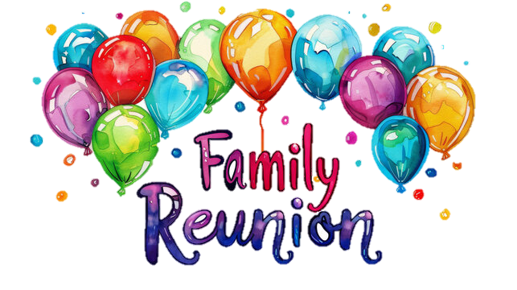
RECREATION & LEISURE SERVICES PARTICIPANT REGISTRATION

RECREATION & LEISURE SERVICES PARTICIPANT REGISTRATION
FORM MUST BE FULLY COMPLETED TO ATTEND! NO EXCEPTIONS.
NAME | ADDRESS | ZIP CODE | WHEELCHAIR  (Y/N)  ATHLETIC TEAMS ONLY  COACH __________________________________________________  ADDRESS ________________________________________________  PHONE __________________________________________________  ASS’T COACH _____________________________________________  ADDRESS ________________________________________________  PHONE __________________________________________________ | B/W/O | M/F | AGE CODE | BIRTHDATE  (M/D/YR)

NAME | ADDRESS | ZIP CODE | WHEELCHAIR  (Y/N)  ATHLETIC TEAMS ONLY  COACH __________________________________________________  ADDRESS ________________________________________________  PHONE __________________________________________________  ASS’T COACH _____________________________________________  ADDRESS ________________________________________________  PHONE __________________________________________________ | B/W/O | M/F | AGE CODE | BIRTHDATE  (M/D/YR)
FORM MUST BE FULLY COMPLETED TO ATTEND! NO EXCEPTIONS.
RECREATION & LEISURE SERVICES PARTICIPANT REGISTRATION
NAME | ADDRESS | ZIP CODE | WHEELCHAIR  (Y/N)  ATHLETIC TEAMS ONLY  COACH __________________________________________________  ADDRESS ________________________________________________  PHONE __________________________________________________  ASS’T COACH _____________________________________________  ADDRESS ________________________________________________  PHONE __________________________________________________ | B/W/O | M/F | AGE CODE | BIRTHDATE  (M/D/YR)
RECREATION & LEISURE SERVICES PARTICIPANT REGISTRATION
FORM MUST BE FULLY COMPLETED TO ATTEND! NO EXCEPTIONS.


