application sample packet
City of Savannah Community Gardens


City of Savannah
Office of Sustainability
Please note that the documents provided in this packet are for illustrative purposes only. You must submit these documents with your application and ensure the information reflects your garden.
- Sample Letter of Intent
- Sample drawing of the proposed layout
- Sample Budget & Proposed Building Materials
- Sample Garden Plot Reservation Form

SAMPLE LETTER OF INTENT

City of Savannah Community Garden Program

[Date]

City of Savannah
P.O. Box 1027
Savannah, GA 31402

RE: Community Garden Letter of Intent Dear City Staff:
I submit this Letter of Intent to notify the City of Savannah that [your name or your organization]’s intent to submit a proposal for the City’s Community Garden Program.

[Your name/organization] wishes to express our interest to start a community garden at provide the general location or address of a property for the proposed garden]. We are hoping to establish this garden with the purpose of [state the purpose of the community garden, ex. growing our own food, educating the public, providing a space to gather, etc.]. We intend to grow [what type of garden is the group wishing to start? Vegetable, flower, mixed, etc.] in [neighborhood name].

[Name] will be our main point of contact for the purposes of the application process and can be reached at:
- Mailing Address
- Phone Number
- Email Address

[Include anything else that you’d like to share]. Thank you for this opportunity to participate in the Community Garden Program.

Sincerely,

Your Name

Please note that this document has been created for illustrative purposes only. Your proposed garden layout may be simple and hand-drawn, as long as it contains the components that we have requested. When creating your garden design, consider:
- Tree cover & adjacent buildings that may leave part of the lot in shade for certain parts of the day
- Plot sizes and how they may be laid out
- Bulletin board for events, messages, and listing a point of contact (POC). Please note that it is required to list a POC, even just an email address, when using a city lot
- Your water source
- Any setback requirements (zoning)

For more details, please review our Community Gardens Manual.

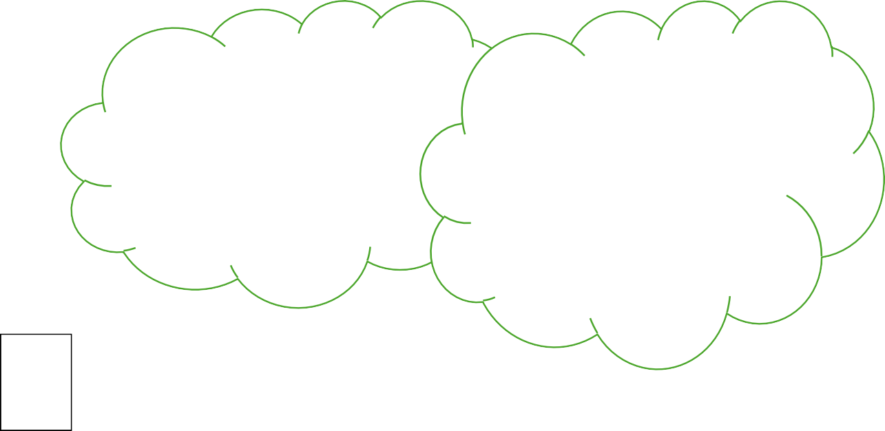
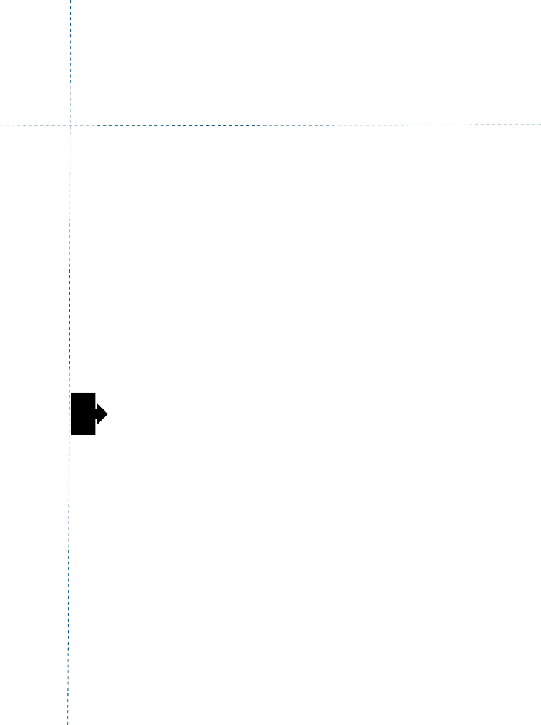




Shared Garden Bed
10’
set Back
20’ Set Back
Tree Cover
Tree Cover
10’
setback
Water Tap
Shared Garden Bed
Largo DR.
Residence

Community Garden Budget Sample

Garden Name:
Date:

Use this sample budget, which outlines common garden-related expenses, as a guide for listing the anticipated costs of items planned by the garden group. For existing gardens, listed items should reflect known and ongoing expenses. Please note that the dollar amounts shown in the sample budget are for illustrative purposes only and do not represent actual cost estimates.
Item | Quantity | Cost | Note
Water bill |  | $80
Water system (hoses, barrels) | 1 | $80
Hand tools & wheelbarrows | 1 | $300
Garden bed | 3 | $100 per bed/$300 | Purchased from Home Depot
Soil
Woodchips & mulch |  |  | Chatham County
Compost or topsoil | 10 Bag
Garden Sign | 1 | $80
TOTAL
How to Build Community Garden – Sample Budget

Community Garden Plot Reservation Form (if applicable)
Garden Name: ___________________________________________

Name:
Address:
Phone Number:
Email Address:
Preferred Plot Size:
☐ Small (4x4 ft)
☐ Medium (8x8 ft)
☐ Large (10x10 ft)
☐ Other Size ( x )
Requested Plot Number (if applicable): ________________
Membership Fees:
☐ Initial Registration Fee: $25 (one-time)
☐ Monthly Garden Bed & Water Fee: $20 per month
☐ Quarterly Garden Bed & Water Fee: $55 per quarter
Total Due: $_________
Agreement
I agree to follow all Community Garden rules, policies, and guidelines. I understand that fees collected contributed to the Community Garden Fund for maintenance, water supply, and shared resources.
Signature of Member: ________________
Date: ________________

Garden Administration
Garden Manager Name: _______________________________
Garden Manager Signature: ____________________________
Date: ___________________

